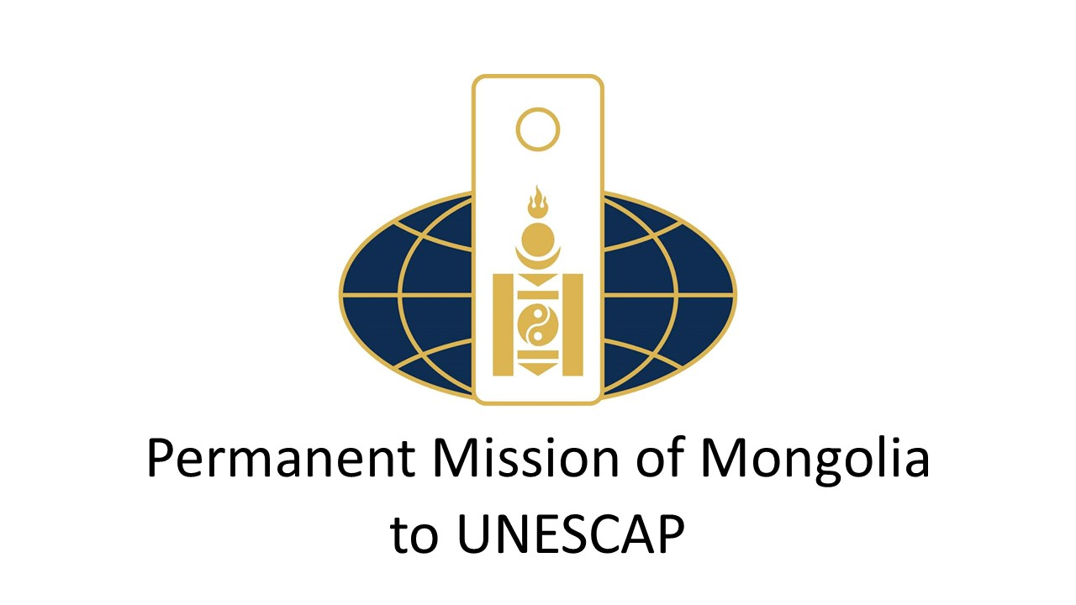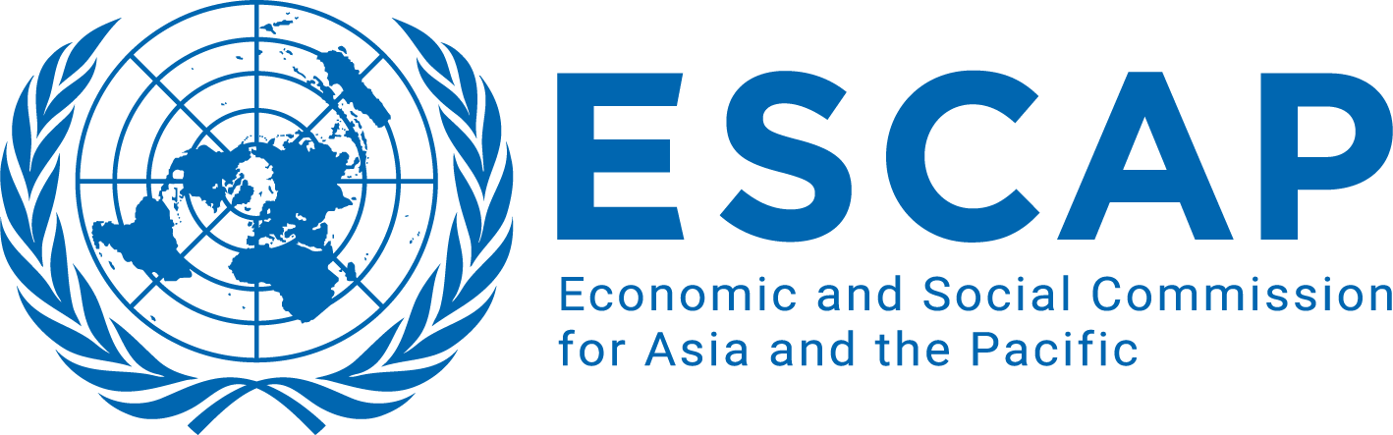

**Sponsors:**

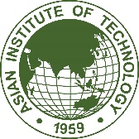

**Draft programme**

**SIDE Event on**

**“****digital innovations for sustainable development in lldc”**

**at the 80th Session of the Commission of UN ESCAP**

|  |  |
| --- | --- |
| Monday, April 22, 2024  13:15 – 14:15  Conference Room 3, Level 1, United Nations Conference Center  Bangkok, Thailand | |
| 12 mins  Opening session | *Welcoming remarks* by Mr. Dulguun Damdin-Od, Executive Director of ITTLLDC |
| *Opening remarks* by H.E. Ms. Battsetseg Batmunkh, Head of Delegation, Minister for Foreign Affairs of Mongolia |
| *Opening remarks* by Ms. Armida Salsiah Alisjahbana, Under-Secretary-General of the United Nations and Executive Secretary of ESCAP |
| *Keynote remarks* by Ms. Atsuko Okuda, ITU Regional Director |
| 45 min  Interactive discussion | *Digital Transformation in LLDC*  by Ms. Atsuko Okuda, ITU Regional Director |
| *ICT Development of Mongolia and LLDCs challenges in terms of ICT*  By Mr. Odbayar Erdenetsogt, Foreign Policy Advisor to the President of Mongolia (tbc)  *Introduction* of *Innovation Hubs and Entrepreneurship.* Showcase of successful innovation hubs and entrepreneurship ecosystems that leverage digital technologies to foster economic growth and job creation.  By Mr. Vitaliy Alexandrov, First Secretary and Deputy Permanent Representative of the Republic of Kazakhstan to ESCAP (tbc) |
| *Leveraging digital connectivity and innovation for SDGs of LLDC*  By Dr. Tae Hyung Kim, Chief of ICT and Development Section, ESCAP |
| Representative from the Asian Institute of Technology (tbc) |
| 3 mins | *Closing remarks* *and key takeaways* by Mr. Dulguun Damdin-Od, Executive Director of ITTLLDC |