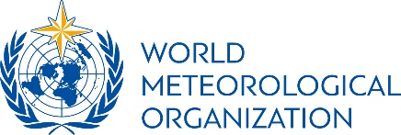  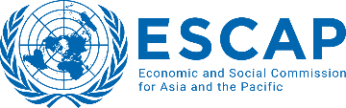

**Side Event at the 80th session of the Commission:**

***Launch event for the State of the Climate in Asia 2023 Report***

**Draft Concept Note**

**Date/time:** Tuesday, 23 April 2024, 12:45 – 14:15 hrs.

**Location:** Conference Room MR-A, UNCC, Bangkok, and online via Zoom

**Organizers:** WMO & ESCAP

**Background**

Asia remains the most disaster-impacted region in 2023, with most natural hazards triggered by climate-related hazards. Floods and storms continued to cause the highest number of mortalities, economic damages and affected the largest number of people. At the same time, the impact of an increasing number of extreme events, such as heat waves was also more severe than in earlier years.

In this context, the State of the Climate in Asia 2023 Report is an effort to bridge gaps between science and disaster risk reduction through evidence-based policy proposals. ESCAP and WMO, working in partnership, will continue to invest in raising climate ambition and accelerating the implementation of sound policy, including the provision of early warnings to all in the region, as a key adaption measure, so that no one is left behind as the climate change crisis continues to evolve.

During the event, key messages of the report will be presented by the lead authors from WMO/ESCAP Members as well as the WMO Deputy Secretary-General, supported by audio-visual material.

**Organization and target audience**

The event is open to all participants of the Commission session, and invited participants online. It is targeted at a broad range of practitioners and researchers: from high-level government representatives from all levels to policy makers, practitioners of disaster risk reduction and climate action, civil society and private sector representatives, donors, and international and regional organisations.

**Objectives and expected outcome**

The [Regional State of Climate reports](https://wmo.int/publication-series/state-of-climate-asia) – together with the [Global State of the Climate Reports](https://wmo.int/publication-series/state-of-global-climate) – are an annual publication of the World Meteorological Organization (WMO), with contributions from regional partners, that informs policy and decision makers and society at large about the climate variability and related weather and climate events of the previous year. Their impacts, placed in their long-term climatic context, along with information about climate action based on information from credible and authoritative sources, will raise awareness of the urgency to act. The State of Climate in Asia 2023 Report, the result of a collaboration between National Meteorological and Hydrological Services (NMHSs) in the region, WMO, ESCAP, and other United Nations (UN) entities in the region, will be launched at this side event (by senior officials and authors).

**Programme**

12.45 – 12:55 Welcome by the moderator and background

Ben Churchill – Director, Regional Office for Asia and the South-West Pacific (tbc)

12:55 – 13:15 Key messages of the Report

Ko Barrett, WMO Deputy-Secretary-General (15’)

13:15 – 13:30 High-level Statements

Tiziana Bonapace – Director, Information and Communications Technology and Disaster Risk Reduction Division

UNDRR (tbc)

13:30 – 14:00 Regional / Country perspectives from the lead authors

China (tbc, online)

Japan (tbc, online)

India (tbc, online)

14:00 – 14:10 Q&A

Discussion facilitated by the moderator

14;10 – 14:15 Wrap up by the moderator